IST 331: Human Centered Design

Northland Bowling Low-Fidelity Prototype

Tristan Epler, Mark Ranieli, Brenden Kokiko, Mark Walsh

3/5/2023

1. Identify the main features and functions of your interface. Write them down in a list.

**Bowling Alley:**

Static info: hours, menu, prices for lane and rentals, tournament info, address, phone number

Dynamic attributes: reserve a lane, plan birthday party, sign up for league

Design thoughts: all static info on main page, buttons to take you to dynamic things.

**Bar/Restaurant:**

Static info: Menu, address, phone number, operation hours

Dynamic info: Reserving a table, Take-out ordering

**Motel:**

Static info: hours, room prices, address, phone number

Dynamic attributes: rooms available, seasonal pricing, specials, amenities

One integrated website that contains all the information for the bar, restaurant and motel instead of 3 different websites for each part of the business.

Create functioning tabs that lead to logical information

1. Each team member sketches out some initial designs on paper. Share your individual ideas with the group. Sketch out your prototype on paper using simple shapes, lines, and labels. Use different colors to indicate different elements, such as buttons, text boxes, or images.

Tristan:

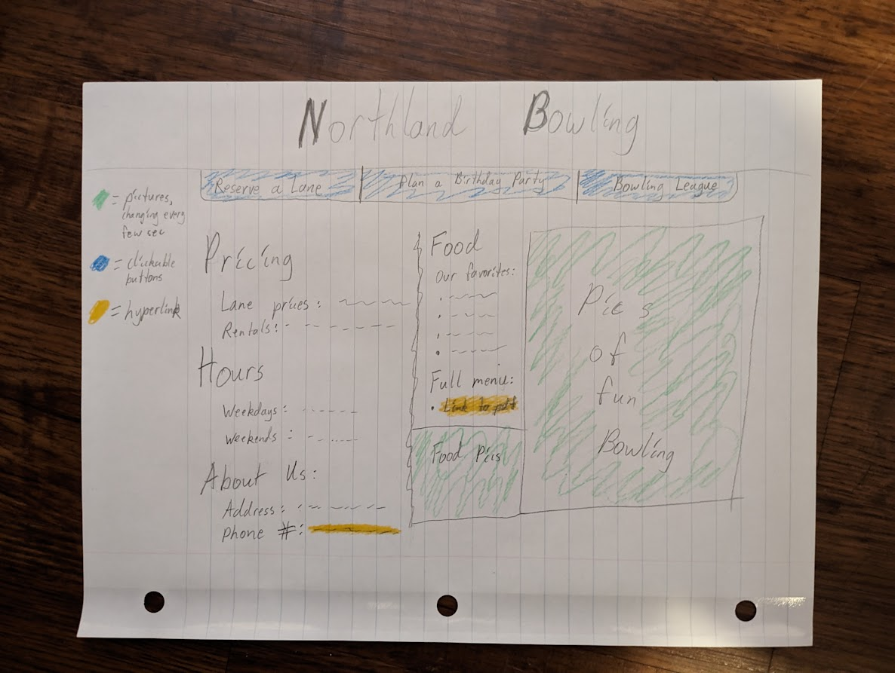

Brenden Kokiko:

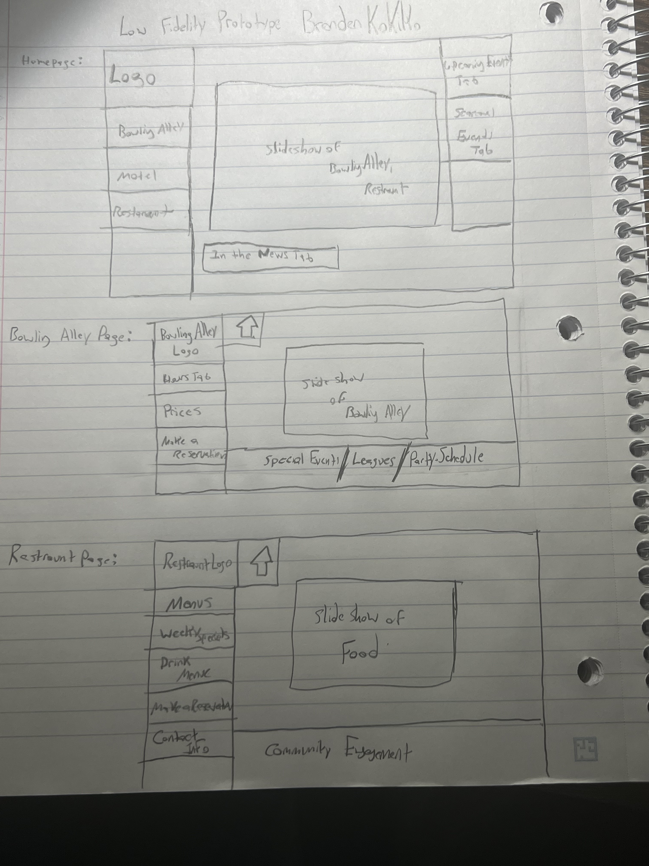

Mark Ranieli

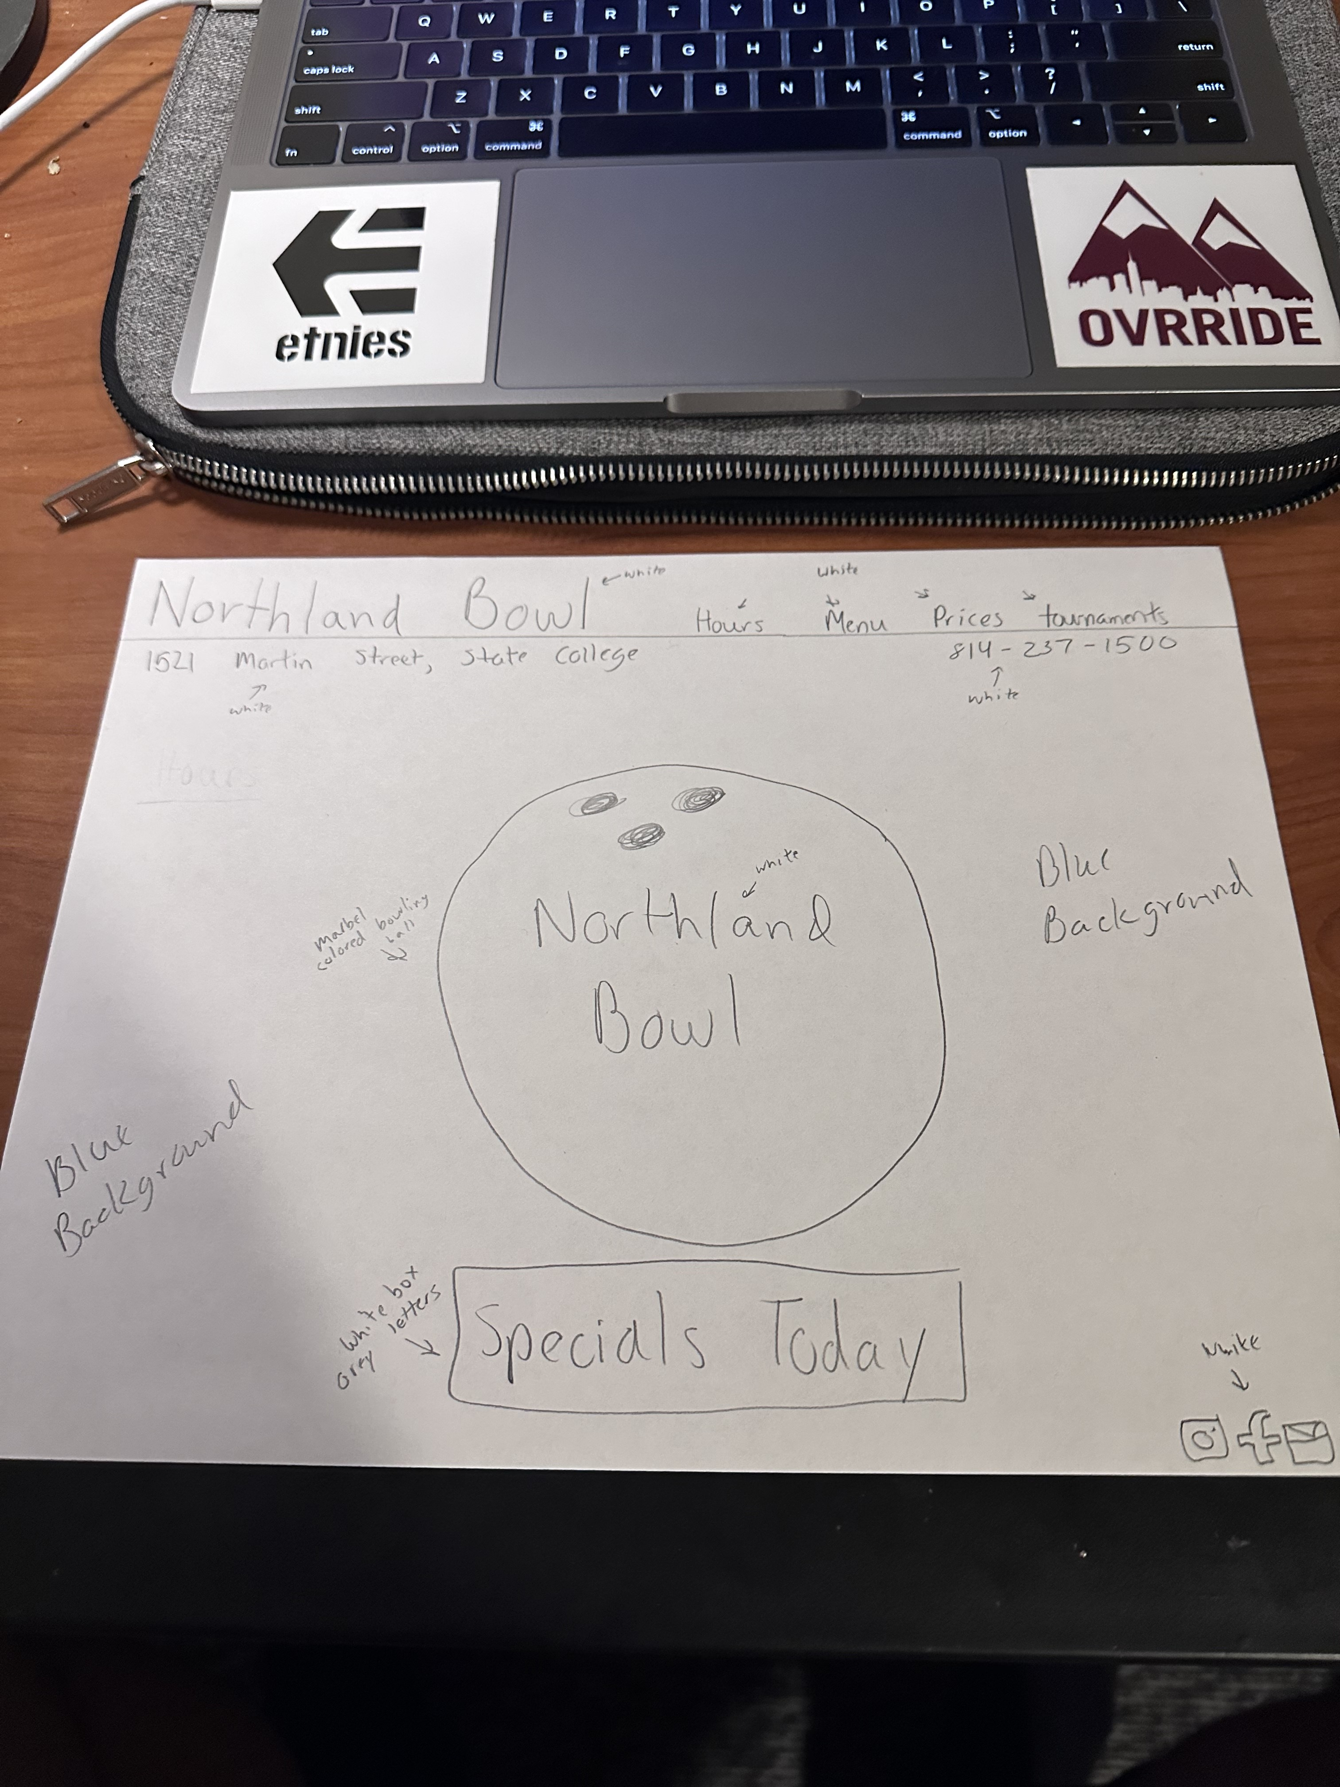

Mark Walsh

Colors: Words Black box letters, white buttons, light blue background, bowling bowl light blue, keep original logo

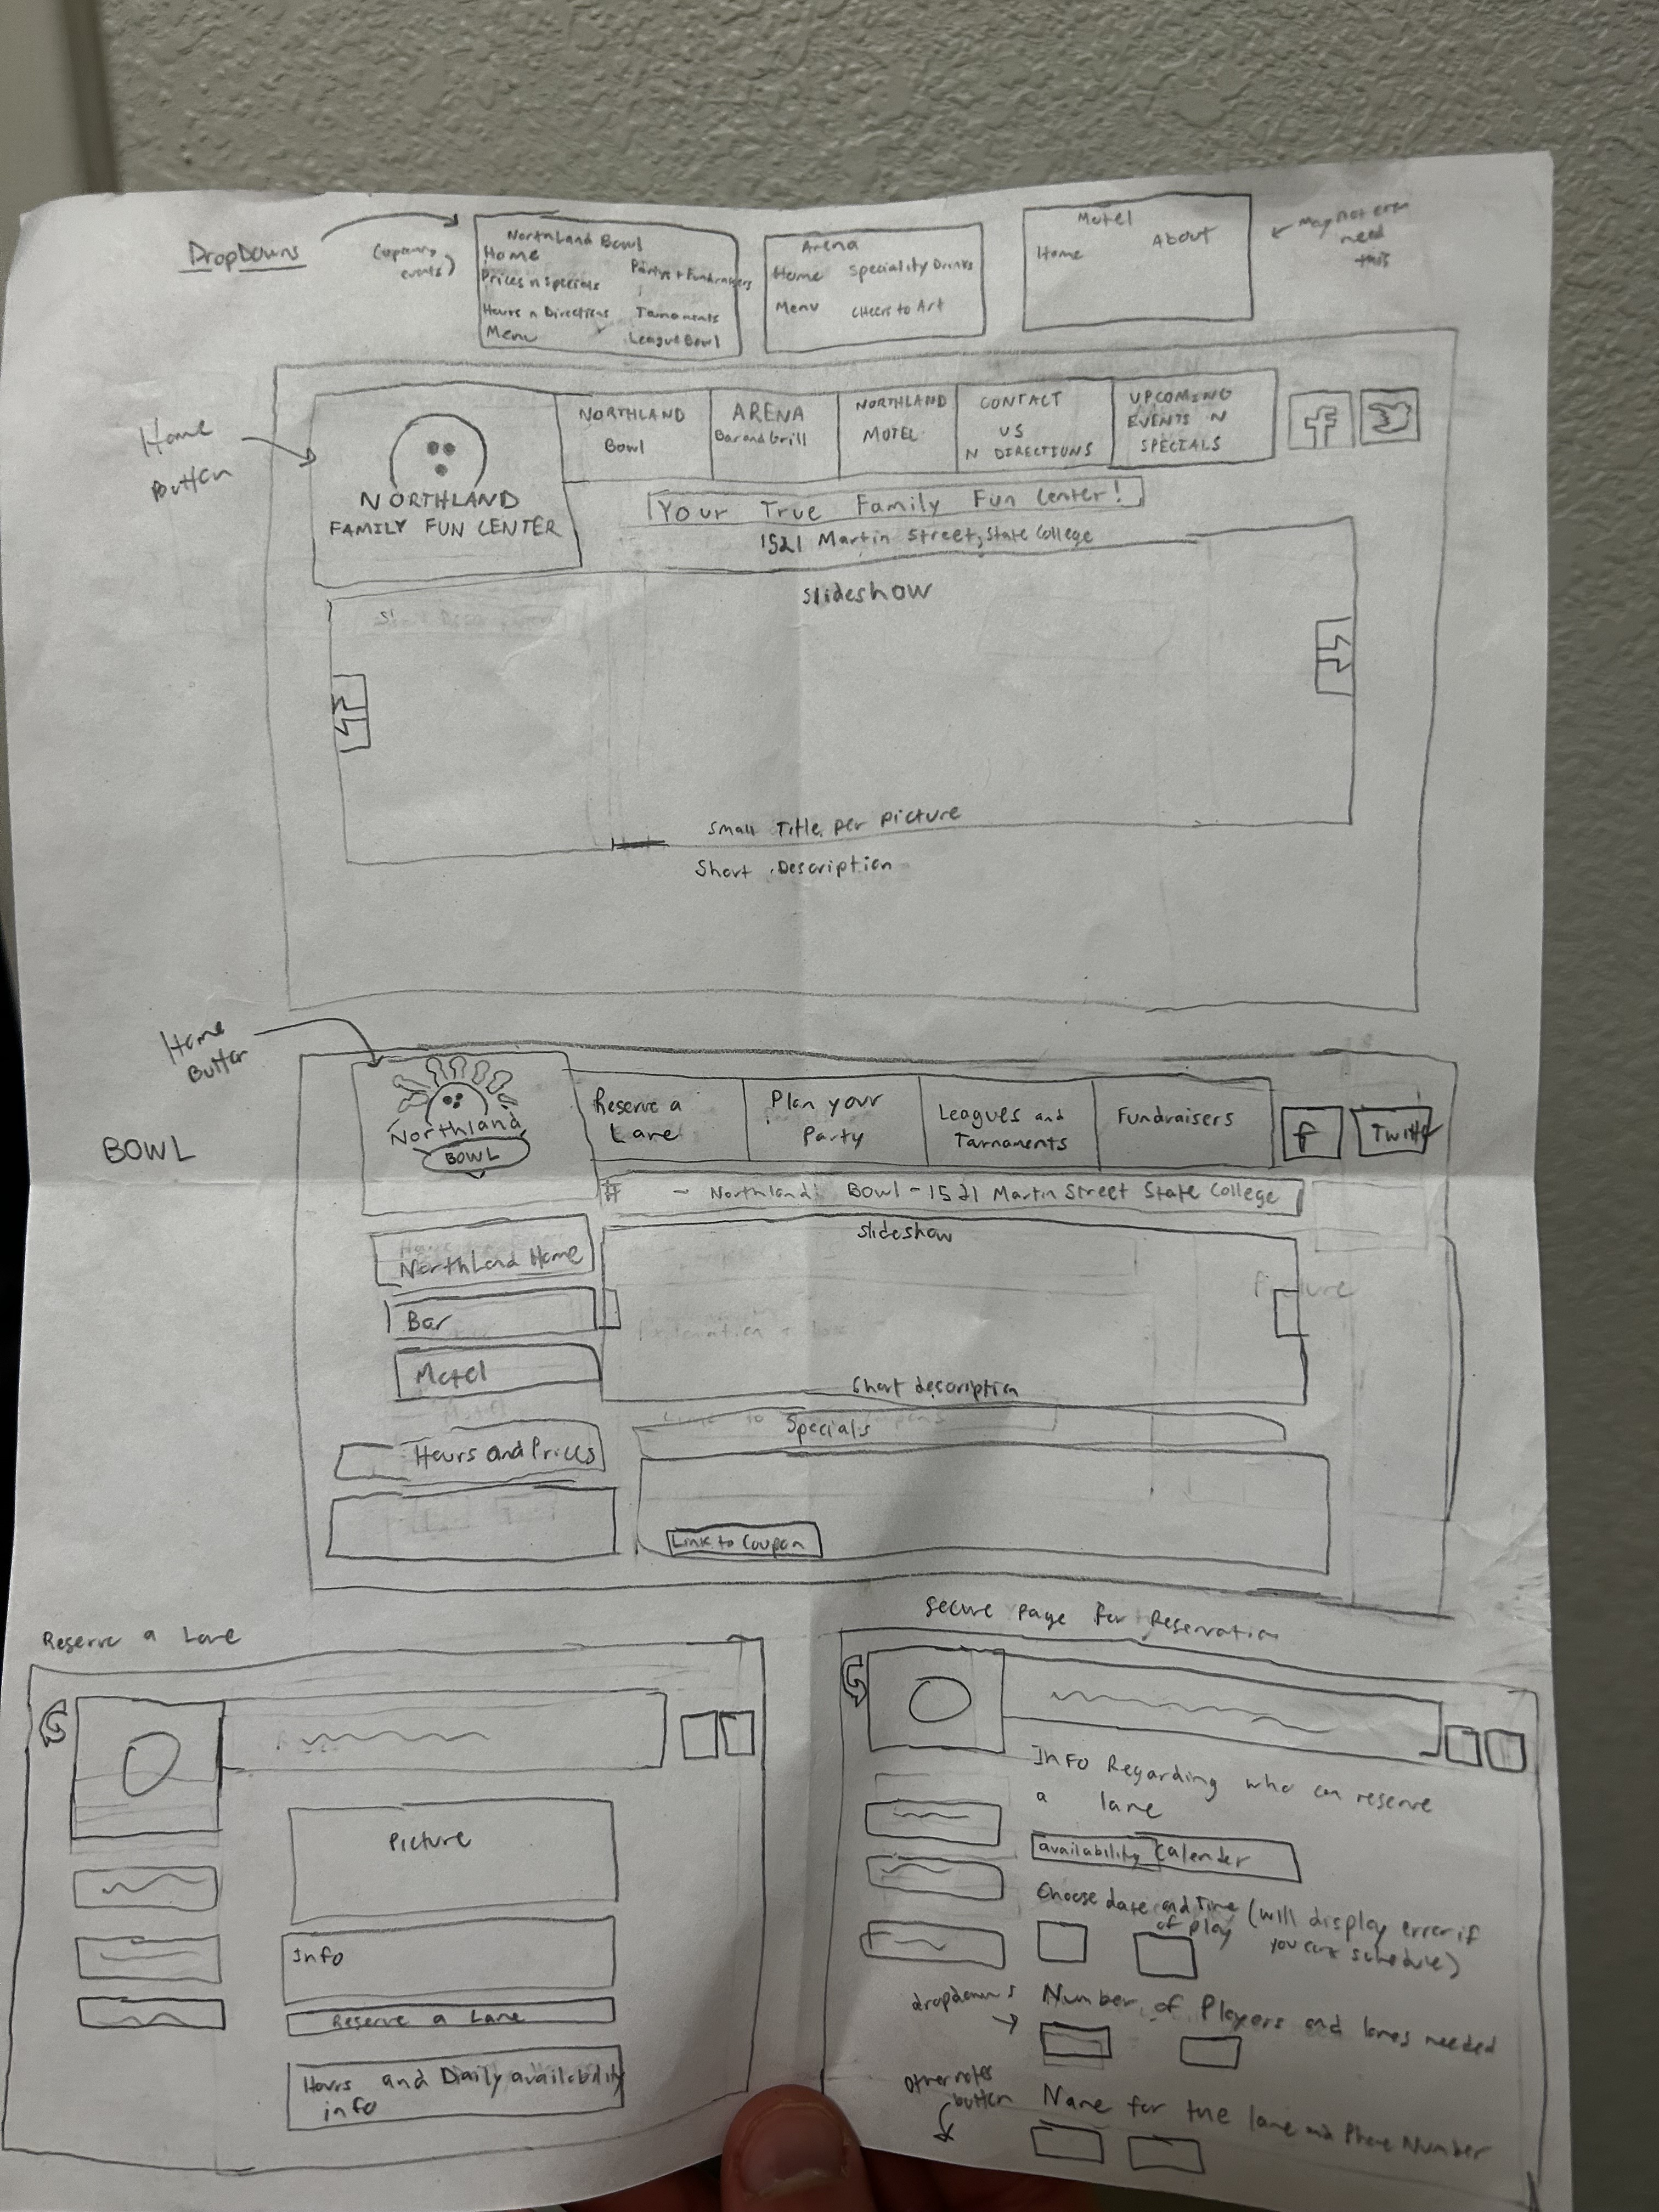

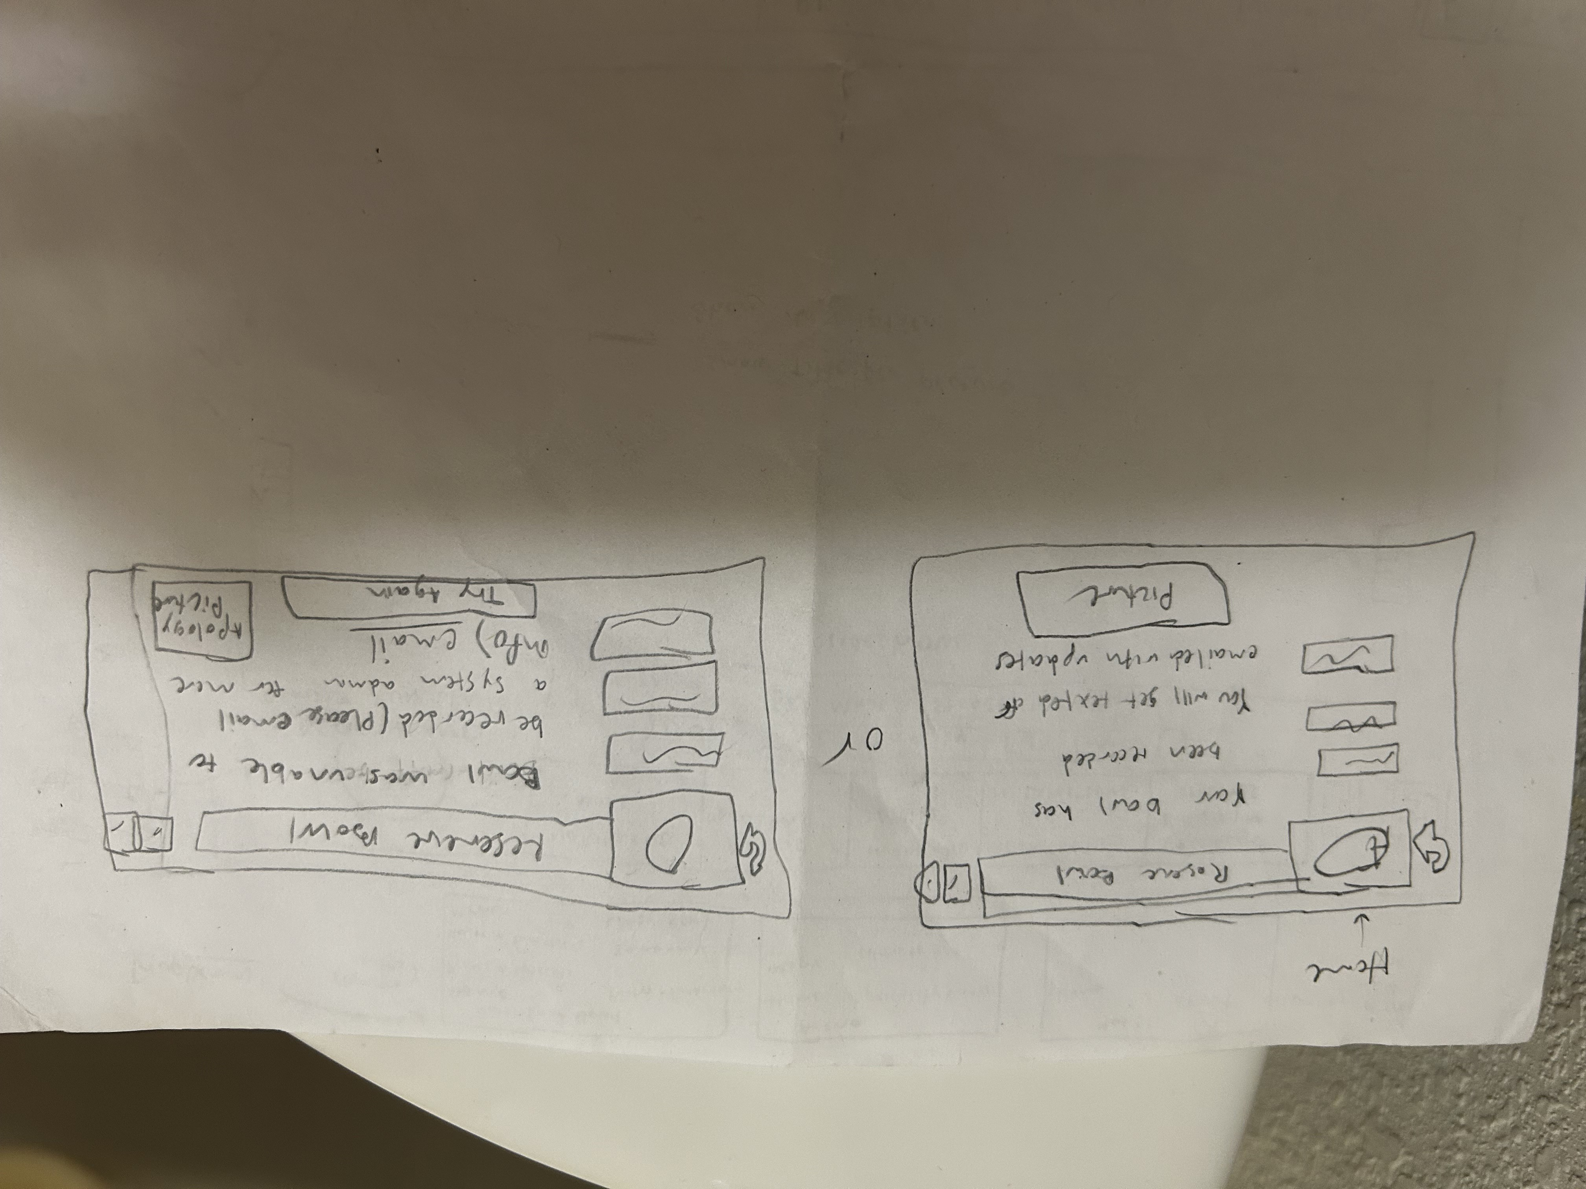

1. The team will then collaborate on sketching a paper prototype that reflects your vision for the redesigned interface for this submission. Combine your ideas to create a group low-fidelity prototype for your interface.

Things we like:

Dark mode (good color scheme)

The use of pictures to keep page from being wordy

Having link or tabs to different places and different information at the top

Northland Bowling logo at the top- redesigned to be prettier

Social media links at bottom of page

Restaurant, Bowling Alley and Motel all tied into one website- different tabs at the top

Large Bowling ball in center of page

Abandon the block style website design for the more free flowing design

1. Test your prototype with at least 3 people. Ask them to perform simple tasks and give feedback on the design, functionality, and usability of your prototype. Record their feedback.

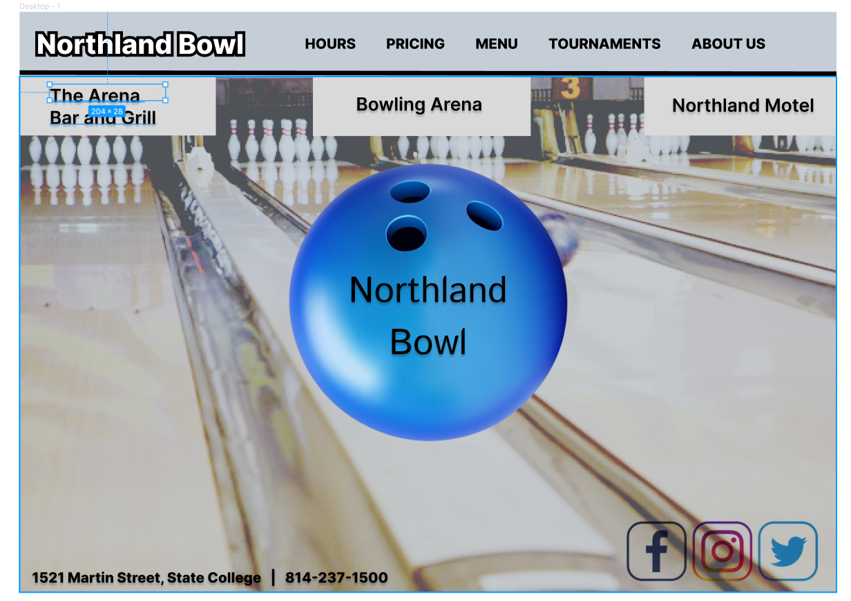

Feedback Received:

Don’t like gaps between tabs up top

Don’t like font on bowling ball

Needs matching color scheme

Bowling ball seems abstract

Would like representation for restaurant and motel

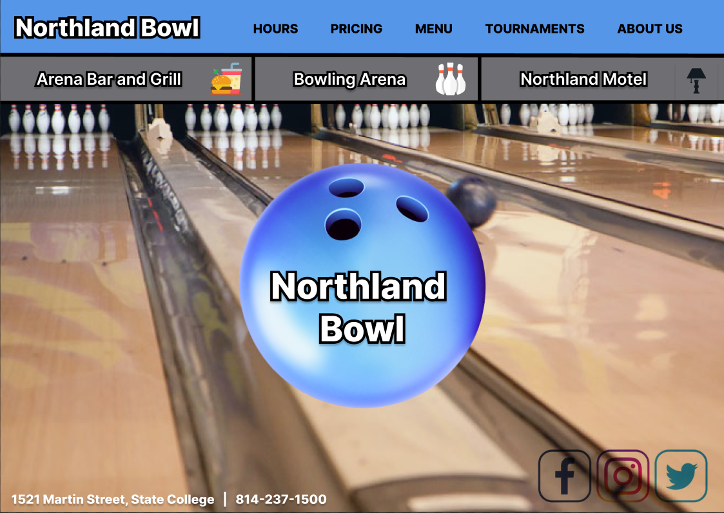

Our application is a main page for Northland Bowling, with access to its two associated businesses- Arena Bar and Grill and Northland Motel. The website has many features. It includes a top menu bar with links to the hours, pricing info, menu, tournaments, and about us sections. There are also prominently displayed links in the form of tabs that can lead the user to Arena Bar and Grill and Northland Motel. The images are included, because we used Figma as our design tool due to all of us being in different locations.

The feedback we received from our test users was helpful in making our design better. The test users wanted the gaps between the 3 tabs at the top removed because the gap looked weird. They didn’t like the font on the bowling ball in the center, and one user didn’t like the inclusion of the bowling ball in the center at all. The users also didn’t like the color scheme of the website. A user also suggested adding icons to the three tabs.

The changes we made included making the tabs connect to each other, changing the color scheme to reflect colors in the background image, and adding icons to the tabs. These changes made the website look much more cohesive, and the information easier to digest.

Low-fidelity prototyping was an important step in our redesign process because it allowed us to quickly test and refine our ideas of what the Northland Bowling Alley website should look like. Creating this prototype also allowed us to gather feedback early in the design process to test our ideas with users allowing for clear identification of issues or improvements that can be made to our design before it is finalized.